Homework 3

Beginning of Report

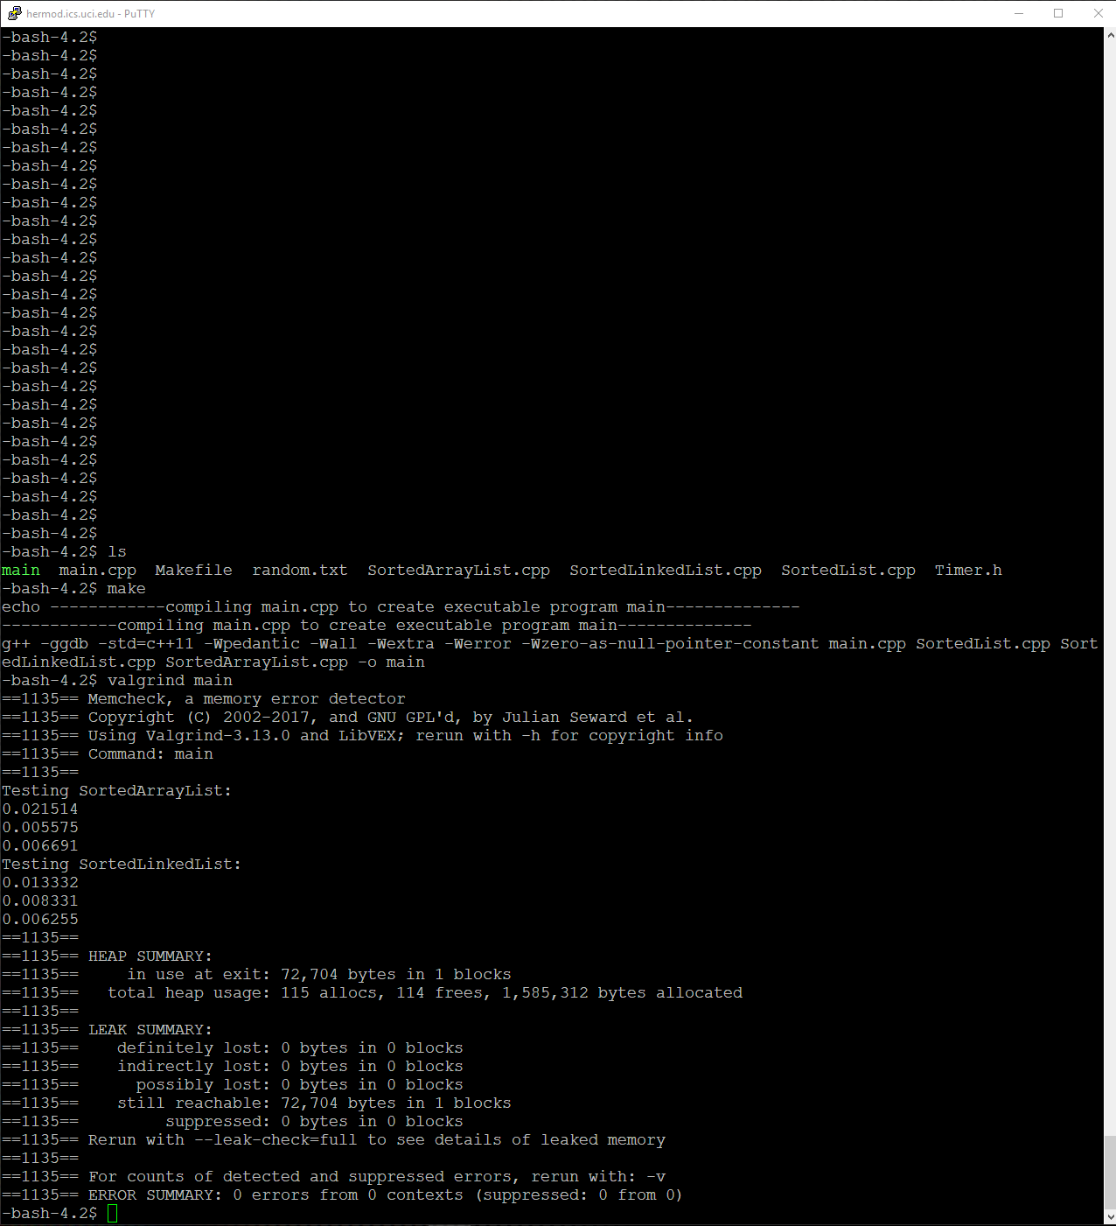

Above is me compiling and running valgrind with a random.txt that has around 100 words.

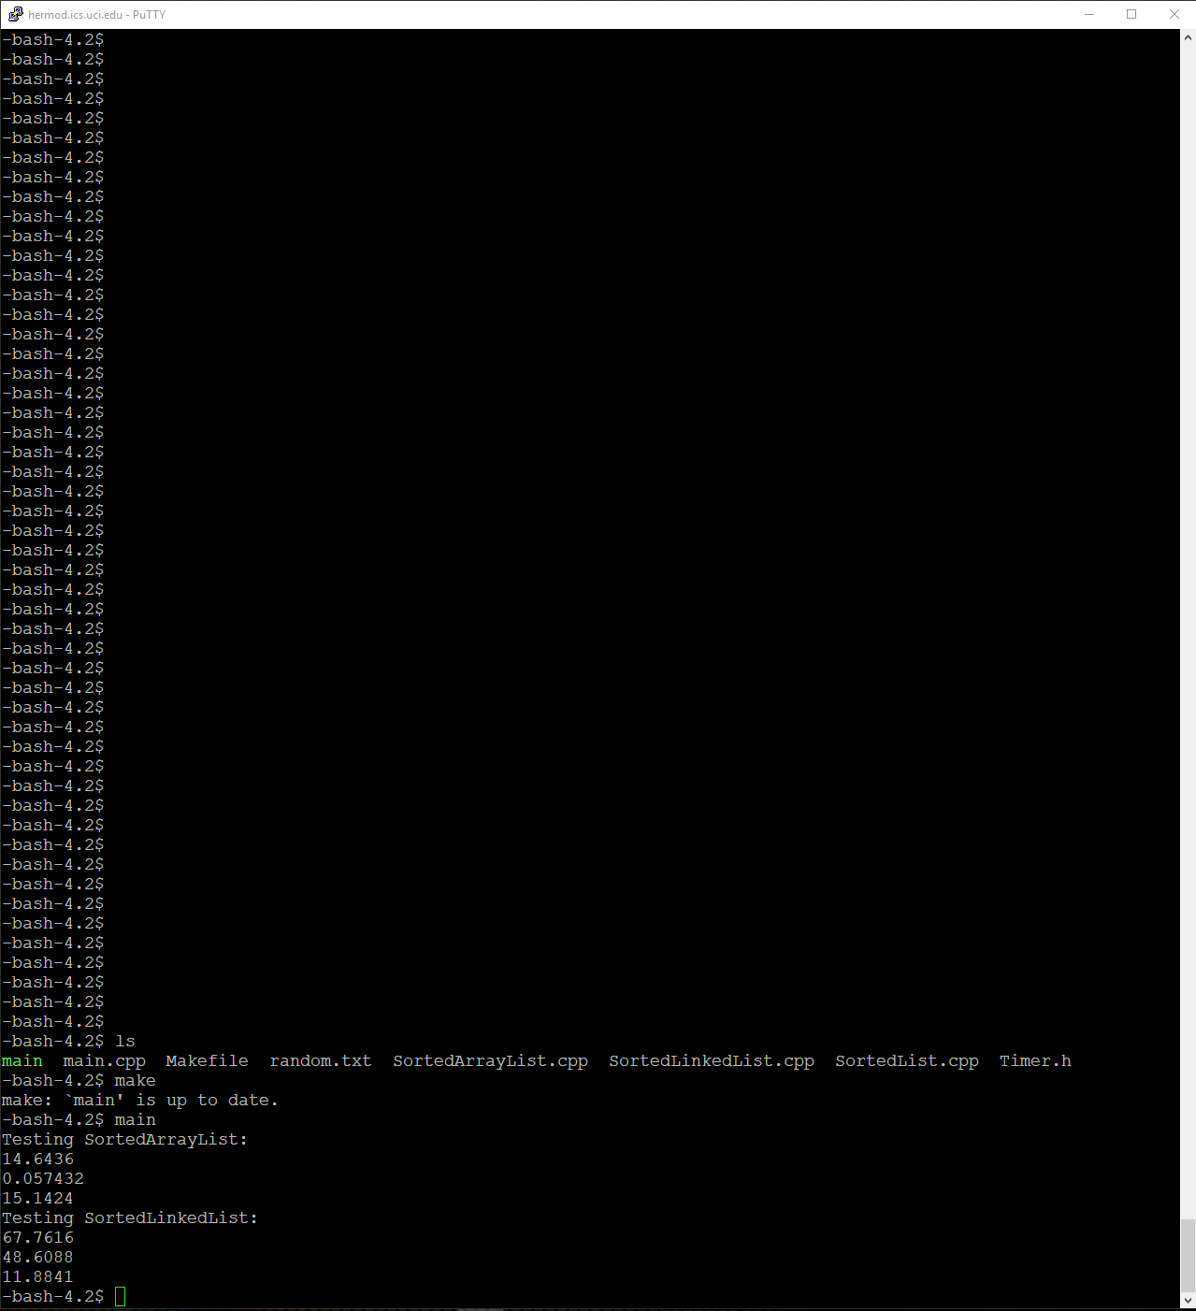

Above is a regular run of the program using a random.txt file that has 45,000 words.

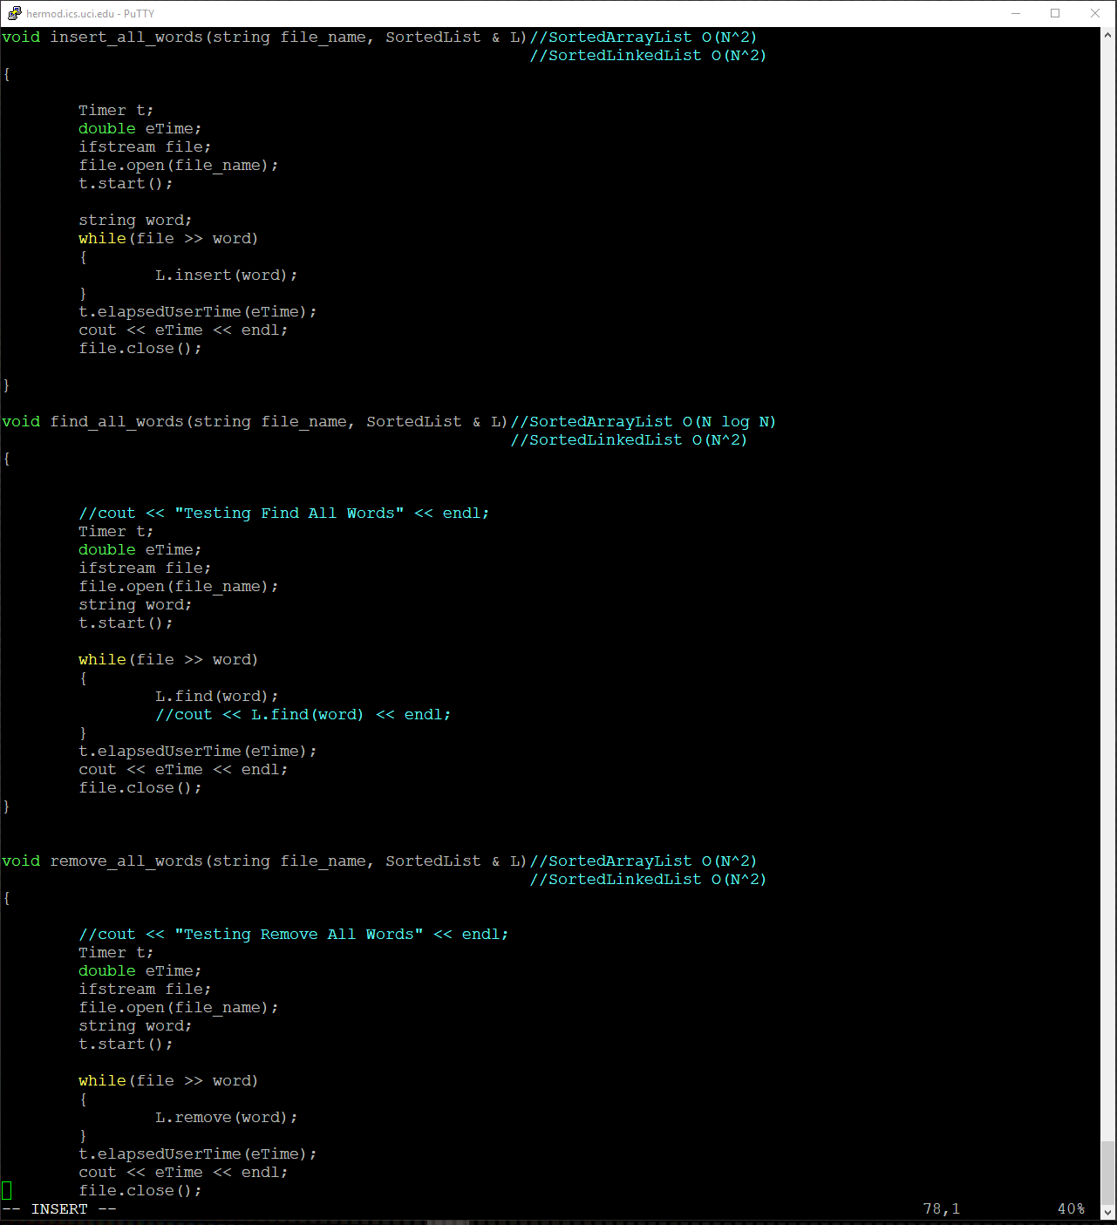

Above is the O(N) of the test functions that use the methods from my SortedArrayList class and my SortedLinkedList class.

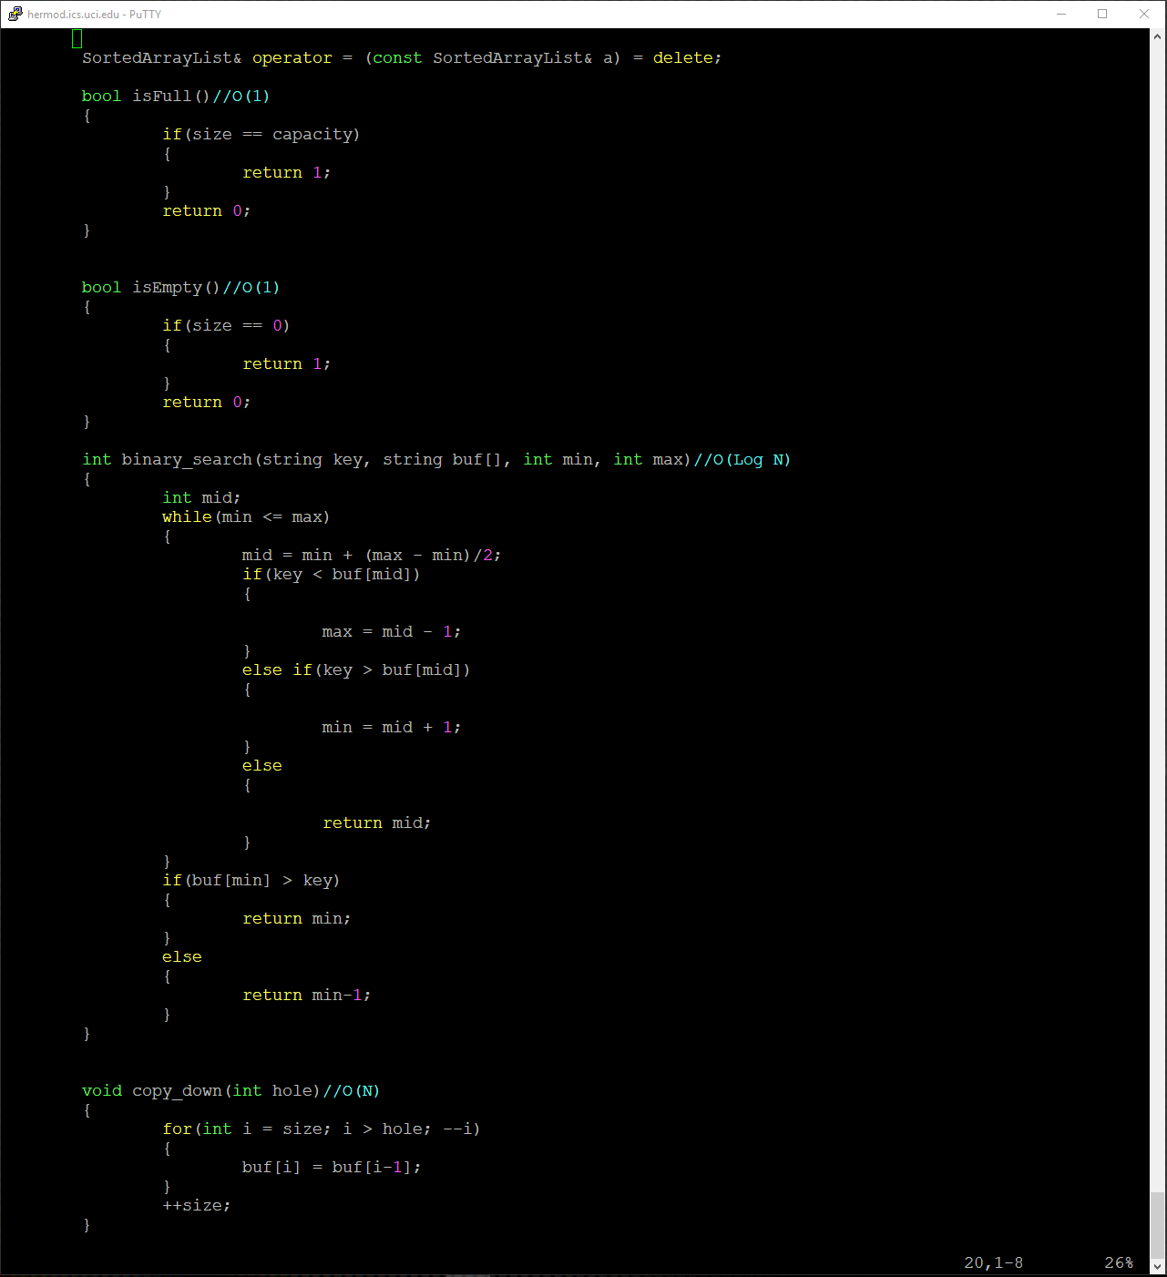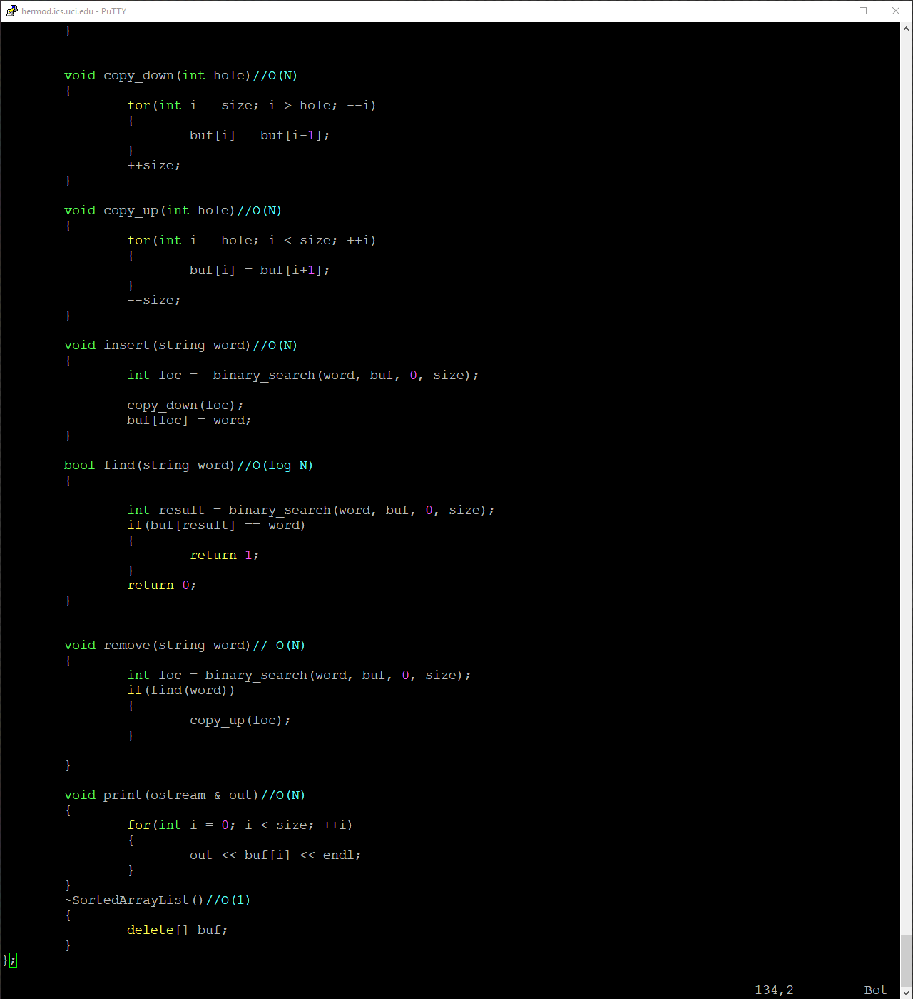

Above is the O(N) of all of my methods in my SortedArrayList class.

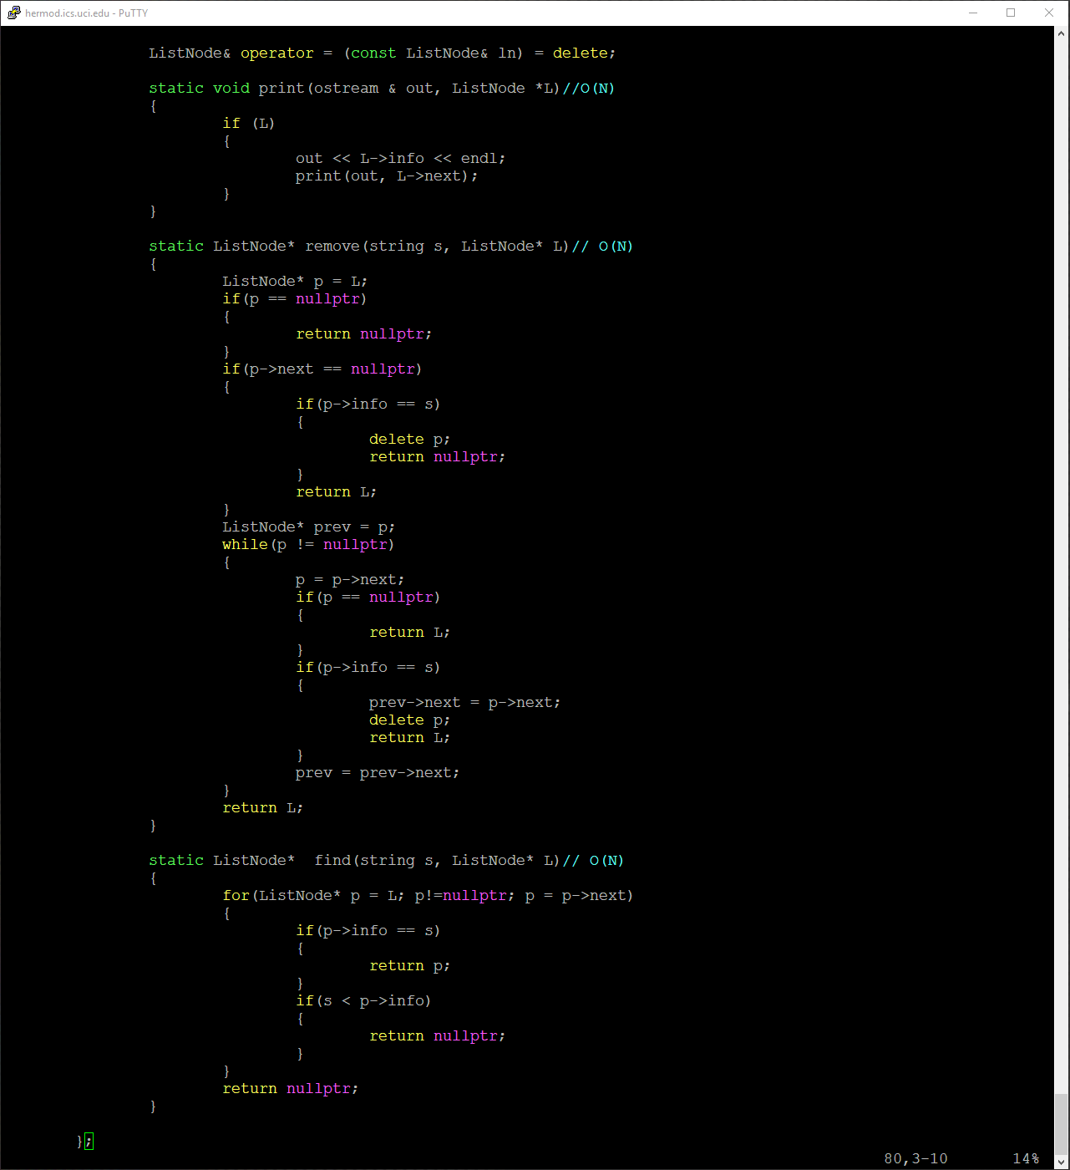

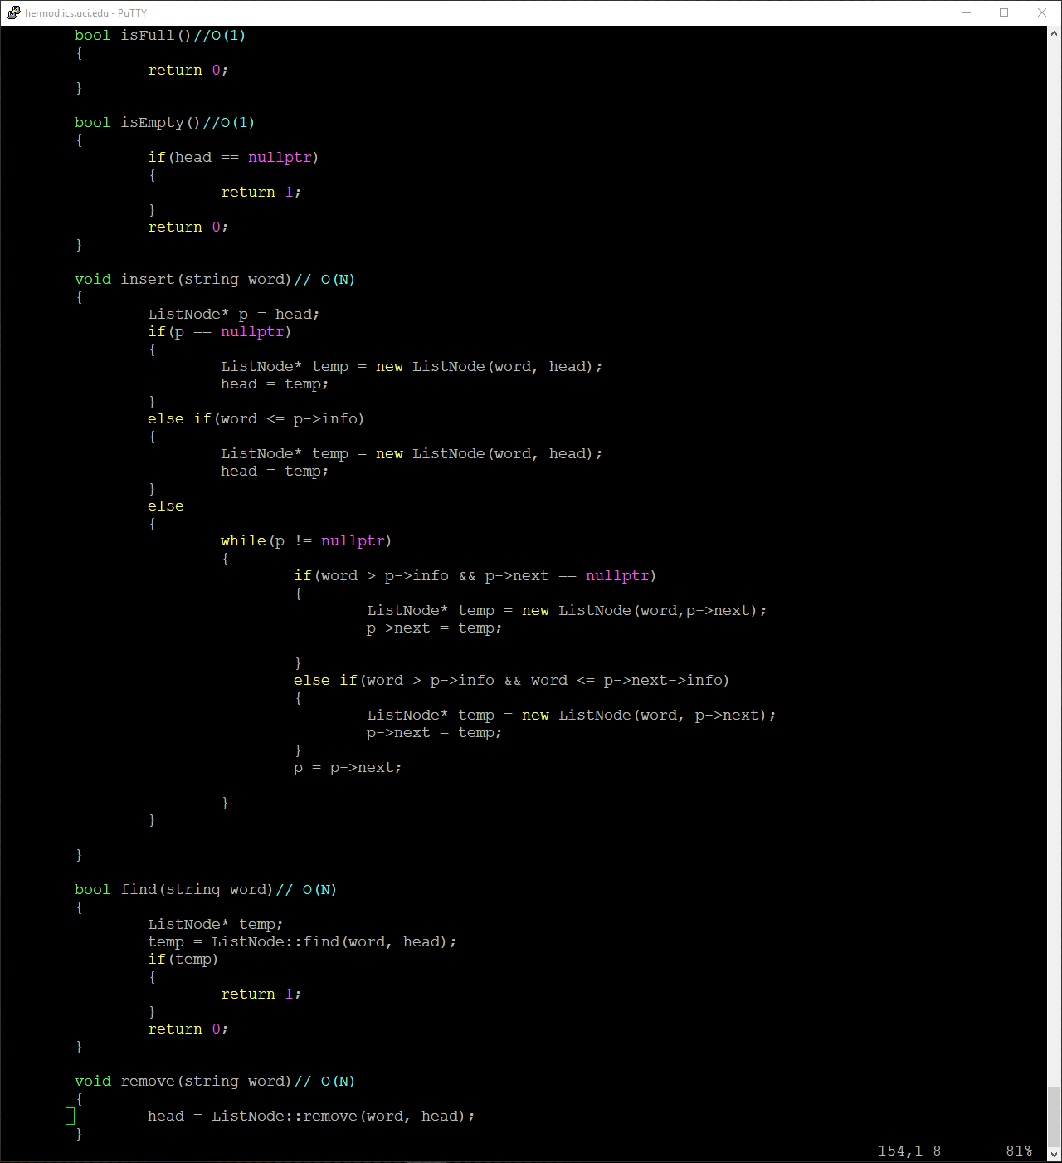Above is the O(N) of my methods and static methods in my SortedLinkedList class.

End of Report